IFB299

Personal portfolio

Group 114

Harry Whittaker

N9478451

Tutor – Pakrash Bhandari

28/10/2016

**Release 1**

**User stories**

The creation and development of user stories is a crucial part of the scrum process because it outlines the requirements of the project from different point of views. I helped to develop the following user stories:

As a Business, I want to be able to store relevant information about my customer’s online orders so that I can more easily track them.

As a Customer, I would like to specify a time and date for the pickup and delivery so that I can place orders ahead of time and better manage my schedule.

As a customer I would like to be able to specify a delivery priority so that the package will be given the needed attention

As a Customer, I would like to specify whether a signature is required, so that sensitive packages are cared for and goods of lesser importance can simply be dropped off at a location.

As a Customer, I wish to receive confirmation emails so that I know my order has been processed correctly.

As a Customer, I wish to be able to check the status of my order so that I can re-organise my schedule if there is a delay.

**Site wireframe**

The site wireframe is important because it is a good way to visualise the website and develop the optimal flow through it. The website was split up in to three sections and they were the customer portal, the employee portal and the manager portal. The following wireframe is for the customer portal.

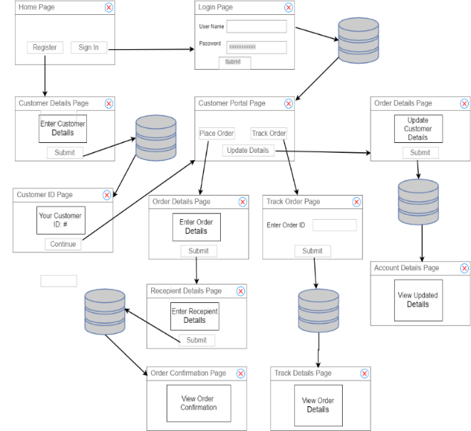

**Log in form**

The login form was used to determine where to send the user depending on their account type. For example, if they were an employee it would direct them to the employee portal. The login forms functionality was mostly developed in release one but there were some bug fixes and updates made in release two.

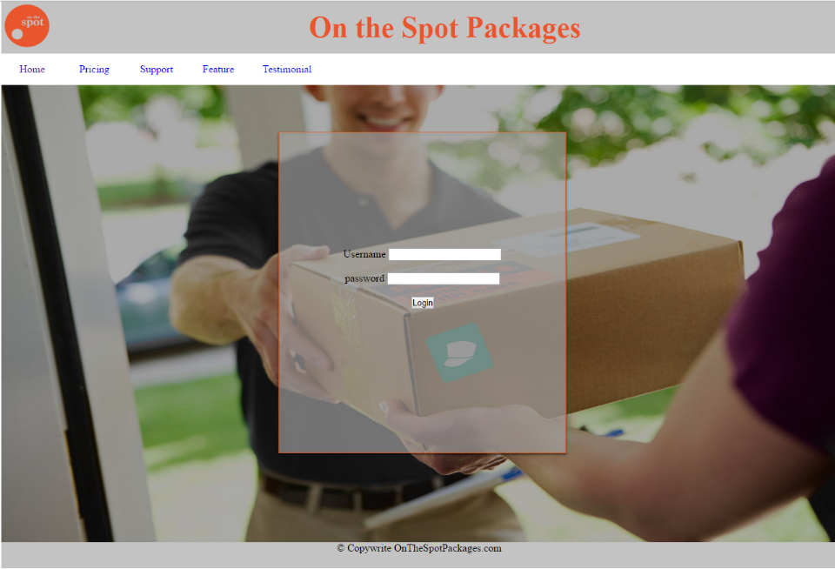

**Update status**

The main function of an employee is to pick up and deliver orders, so the following method was developed for them to log when the order had been processed through each step of the delivery. From the employee portal they would click the ‘delivery schedule’ button that would take them to the following screen.

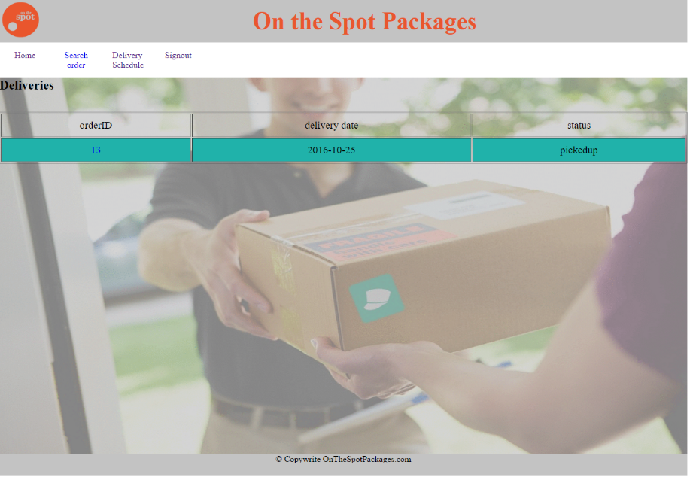

In this screen they would select the order that they wish to update the status of and then they would be directed to this screen.

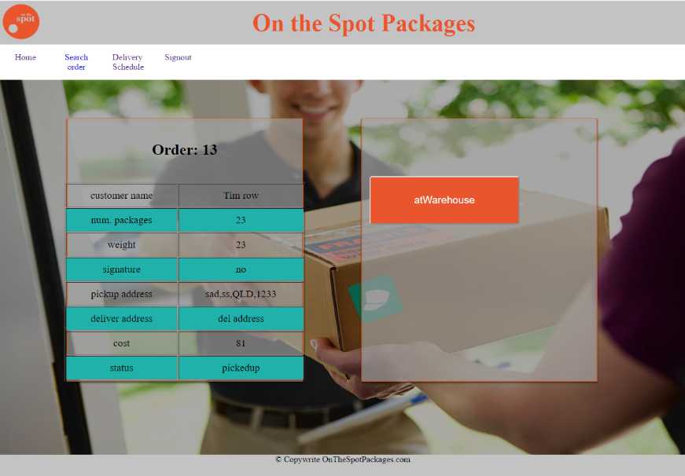

Here they can view the order details and select the button to update the order status to the next step.

**Search order**

The search order function is used when an employee wants to look up the details of an order. In the following form they can input the order ID and then click the submit button.

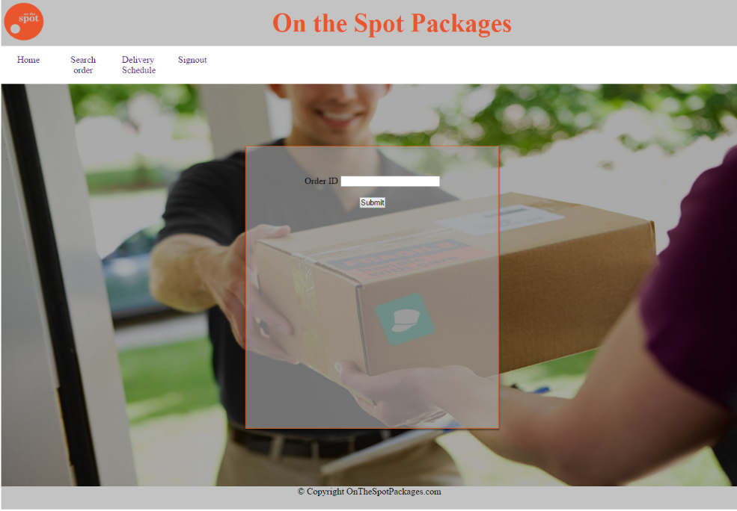

They would then be presented with the relevant order details.

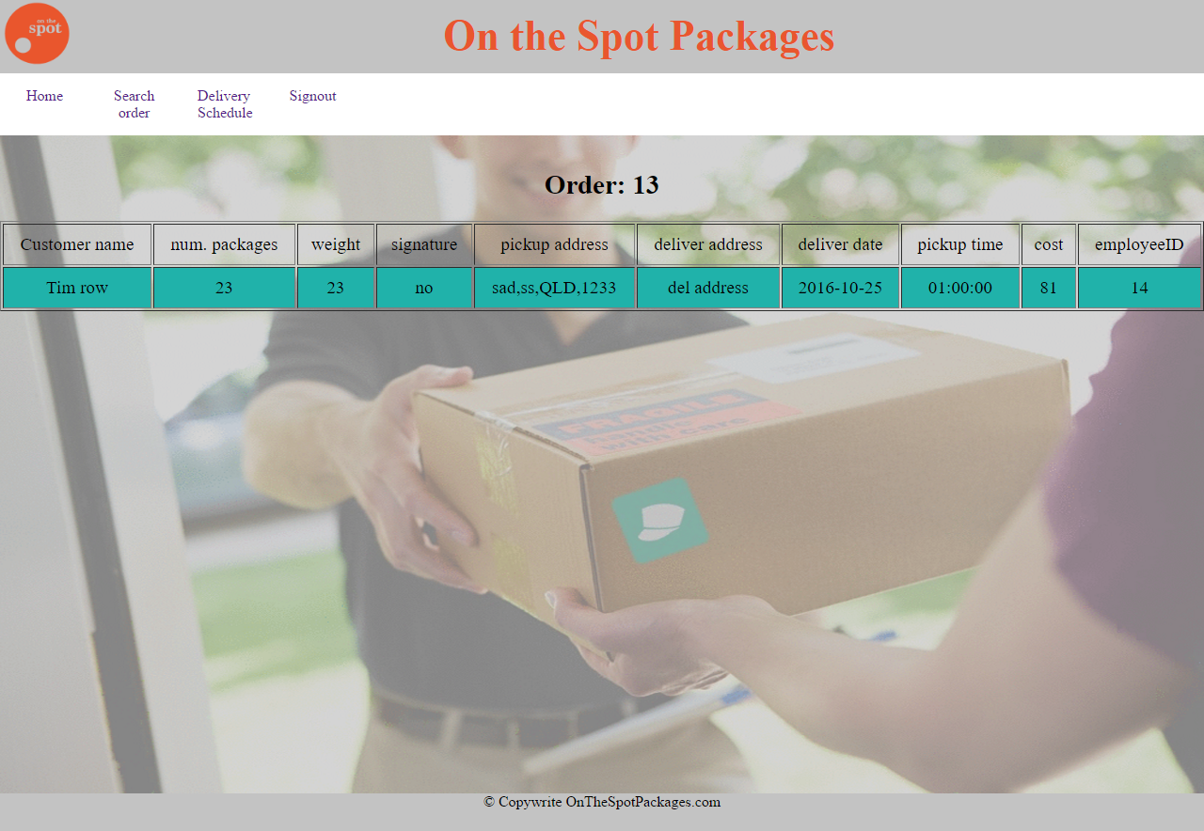

**Release 2**

**Sprint plan**

In release two I worked on sprint plan three, four and five.

**Manager portal**

The manager portal is where the manager is directed after logging in. Here they have the option to navigate to any of the six functions that they may wish to perform.

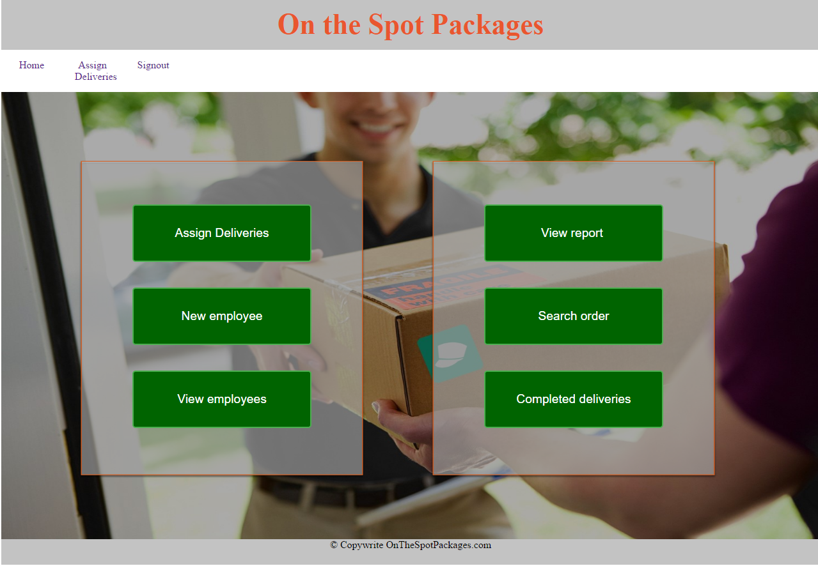

**Assign employee to order**

The manager is the one who assigns the employees to the orders and they can do this by selecting the order that they wish to assign in the assign deliveries page.

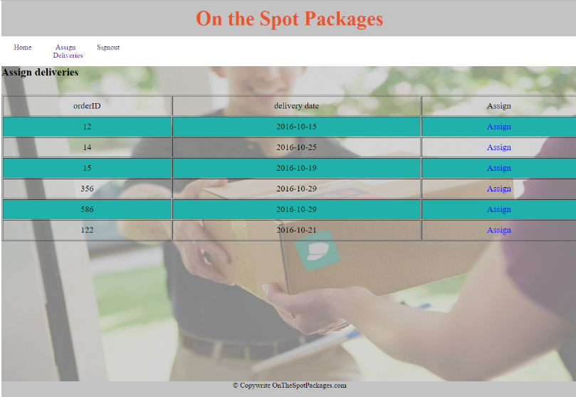

They then can click on the ‘assign’ option in the desired orders row to assign the order. Then they are sent to the following page in which they can select the employee that they wish to assign it too.

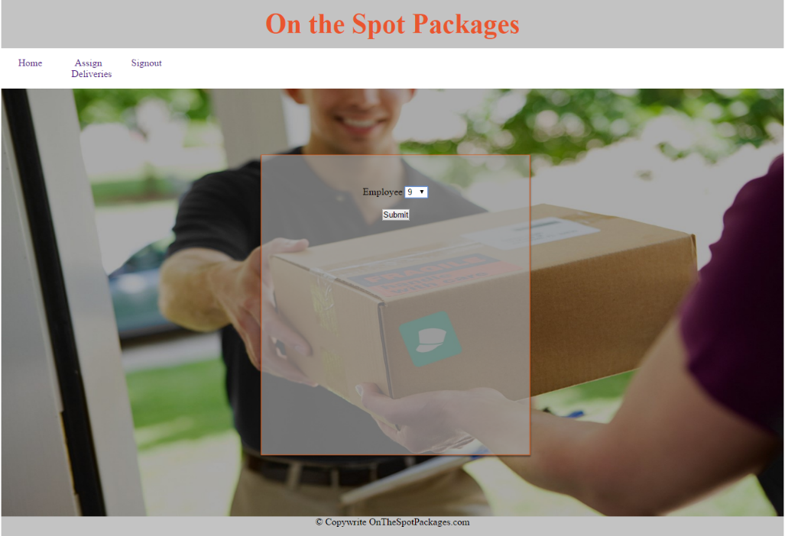

**View employees**

The manager also is responsible for making new employees and there is also an option to view all current employees. This is selecting the ‘view employees’ button on the manager portal.

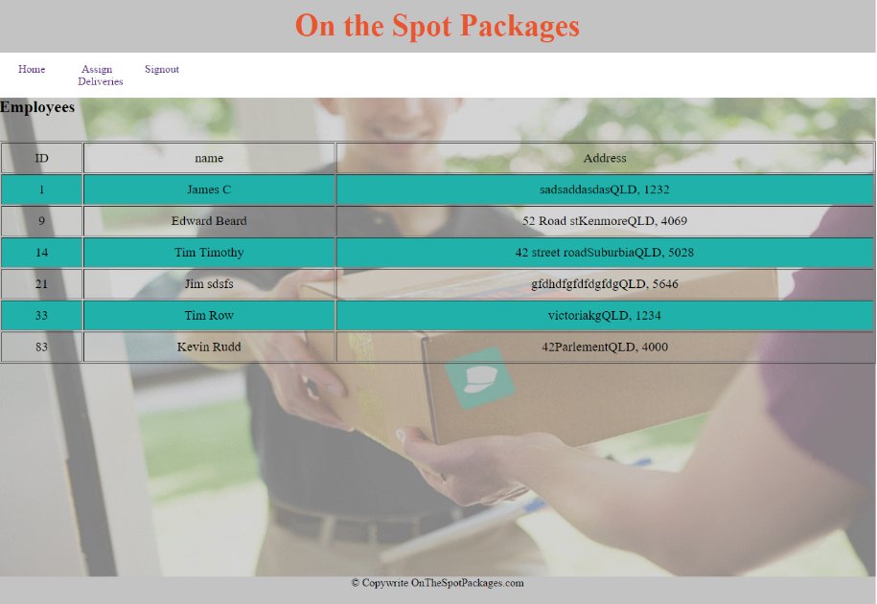

**Manual testing**

Manual testing was done for processes that selenium can’t accommodate for. The following processes were manually tested; manager adding new employee and assigning delivery, employee signing in and updating package status and customer updating their details.

